Questions:-
======================NODE JS Topics 3RI Techlologies=======================
- Foundation
- Introduction to Node JS Framework
- Installing NodeJs
- Using NodeJs to execute scripts.
- Node Package Manager
- package.json configuration
- Global Vs Local Package Installation
- Automating task with Gulp.
- HTTP Protocall
- Building HTTP Server
- Rendering a response.
- Using RePresentational State Transfer.
- Nodemon
=================== EDUREKA =================
- What is Node Js Ans -
Node js is a javascript App build on top of chrome v8 engine.It uses event driven, Non blocking I/O model which work async and on single thread architecture. It is cross platform.
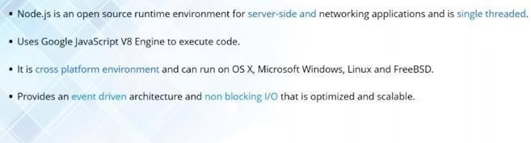
- Why Node Js
Ans - Node Js Follows Client Server Architecture.
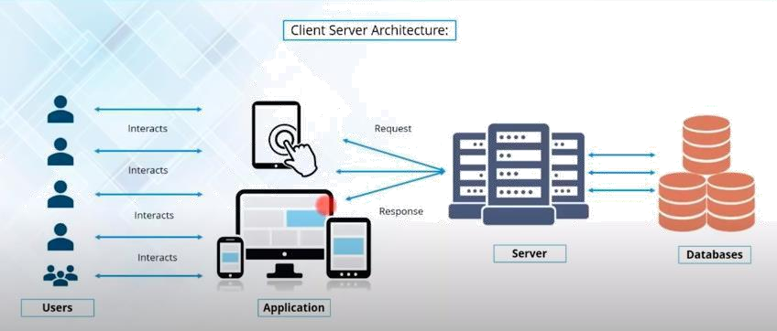

Cleint/Users ------------→ Websites/Apps -----------→ Servers → Databases (REQUEST)
Cleint/Users <----------- Websites/Apps <---------- Servers < Databases (RESPONSE)

OLA/Uber Example -
Uber customer/passenger make request to book cab using uber app. These request are sent to uber server and then further sent to uber database to check nearest available cab.

These cabs info are sent back to customer in form of response.

- What is single Thread and Multi Thread Modal Ans : -
Each request is handles by a sepereate thread.

Disadvantage
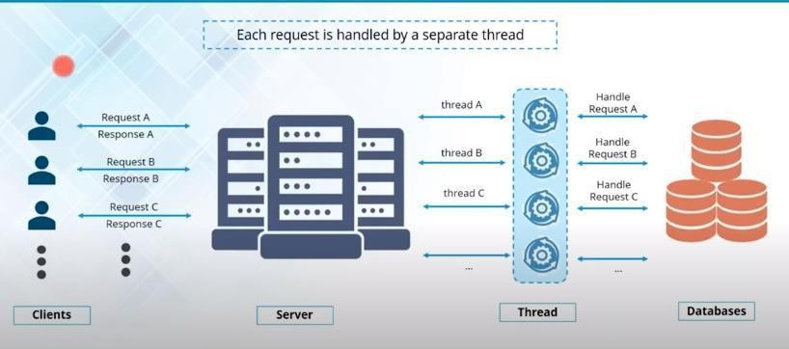
- Number of request = Number of threads.
- if millions of request are coming per seconds we need millions of threads assign to each request which is complex and costly.
Single Thread Modal

Node js is event driven(events like – click, dbl click, mouse event etc). Handle all request asychronous using single thread.
Almost no functions directly performs Input/Output operations, So process never blocks.
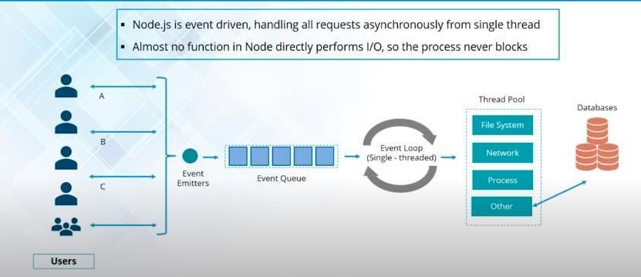

In single thread, when a user perform an activity(click, submit etc), an event is generated. Every New request is a threated as an event. Event emitter allocates those events in event queue which is single thread. These event are executed/processed using event-loop machanism which is called single thread machanism. Single thread takes an event in the queue and sends in the thread pool.
There are differnet operation can be handled in Thread Pool Like File Operations
I/O Operations Network Opeartion
CPU Intensive Operations
The Thread in thread pool also called worker thread takes those operations asychronously(one thread handle all oprations so no blocking happens).

The processing of events in the event queue by event loop is also called event driven Modal or single thread modal.
Multi Thread Vs Event Driven
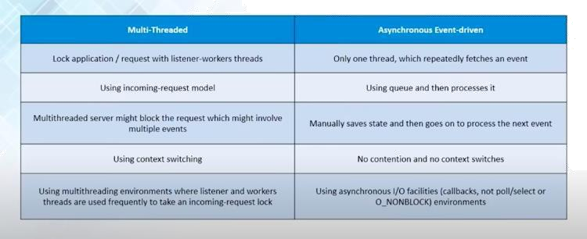

incoming request model – a new thread is allocated for a new request everytime. Multi thread works in synchronous.

UBER EXAMPLE -
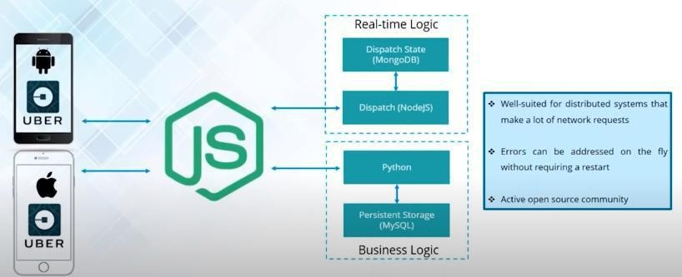

Here there are two DB. Mongo DB for car details and MySql for driver details. Since Node is async so two request can be send simenteniously and get the response.

Error handing is easy and quick in node js.
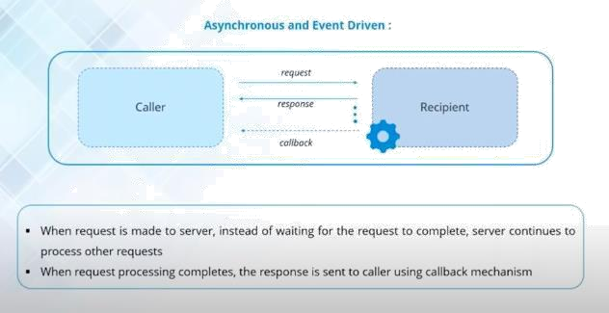

NOTE : - All API in node js are single thread. So one API Never waits another API to respond.
There is a notification machenism used in node js which is a callback function.
NODE JS FEATURES :-
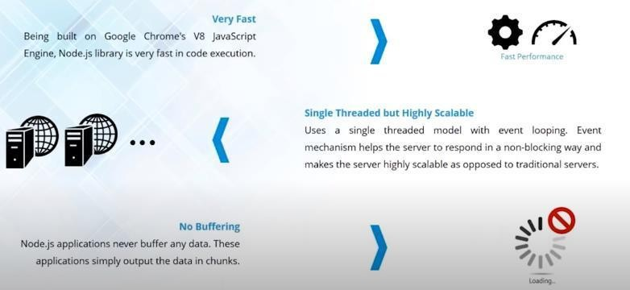
Node Js Installation - https://nodejs.org/en/download/

Simple node js exaple using sync(blocking)

var fs = require('fs');

var data = fs.readFileSync(‘blog.txt’);
console.log(data.toString());
console.log(‘End Here’);

blog.txt hello nodejs.

Output : hello nodejs end here

Async (Non Blocking) :-

var fs = require('fs');

fs.readFile('blog.txt', (err, data) => {
if(err) {
console.log(err)
} else {
setTimeout(function() { | // this request will go to event queue.
console.log('show after 2 sec.');
}, 2000);
}
});
console.log(‘start here’);
output : - start here
show after 2 sec.

NODE JS MODULES :-

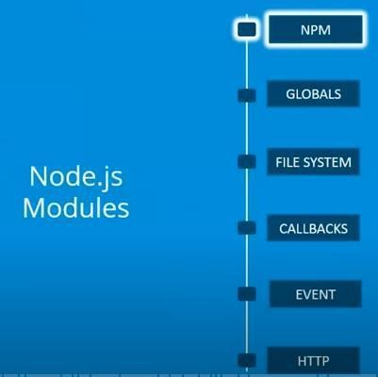
NPM:-

Node package manager. Online utility to download node js packages/dependencies.

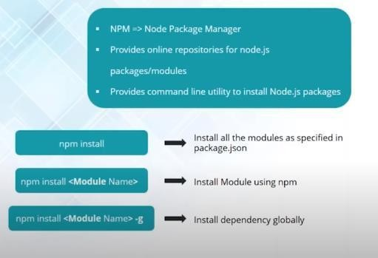

NODE JS FILE SYSTEM MODULES:-
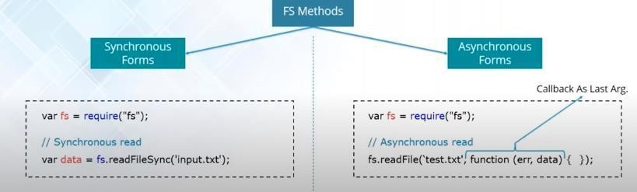

FS MODULE OPERATIONS :-

open | read | write | close
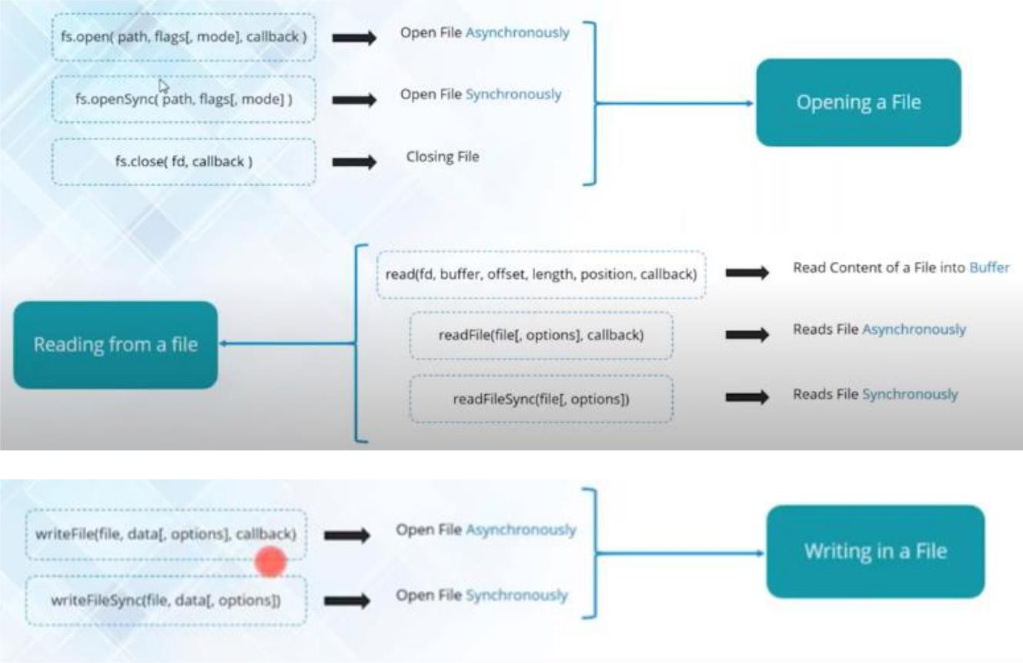

NODE JS CALLBACK:-

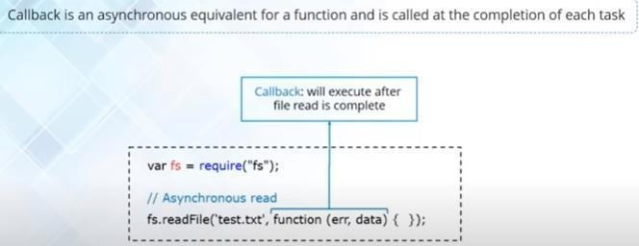
NODE JS EVENTS :-

We can emit our own event using Event Emitter() Method.

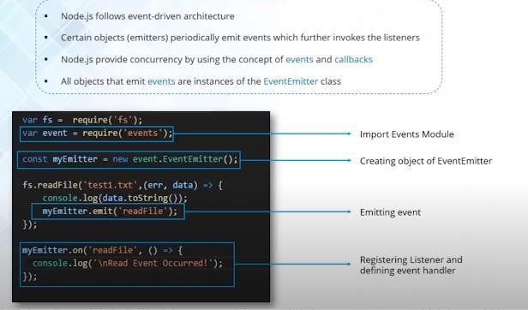

var event = require('events');
var callEmitterEvent = new event.EventEmitter();

var fs = require('fs'); fs.readFile('fileName', (err, data) => {
console.log(data.toString());

callEmitterEvent.emit('readBlog'); // function name
});

});

NODE JS HTTP MODULE :-

Hypertext Transfer Protocall.

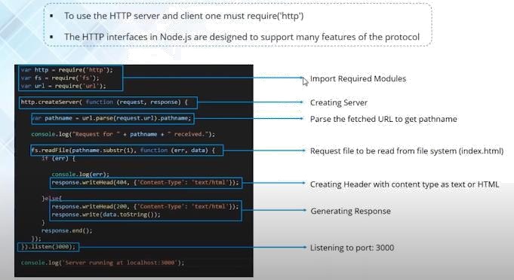

var http = require('http'); var fs = require('fs'); var url = require('url');

http.createServer((request, response) => {

}).listen(3000);

stub in Node.js ?
A small program routine that substitutes for a longer program which is possible to be loaded later or that is remotely located.
Features of stub:
- Stubs can be either anonymous.
- Stubs can be wrapped into existing functions. When we wrap a stub into the existing function the original function is not called.
- Stubs are functions or programs that affect the behavior of components or modules.
- Stubs are dummy objects for testing.
- Stubs implement a pre-programmed response.
Example:
var fs = require('fs')
var writeFileStub = sinon.stub(fs,
'writeFile', function (path, data, cb) {
return cb(null)
})

expect(writeFileStub).to.be.called
writeFileStub.restore()

